Name of Student : Raghav Mahesh Sarda PRN: 25070122235
Subject: Programming with Java Semester: III
ASSIGNMENT No : 6 Year: AY 2026-27
TITLE : Inner and Anonymous Classes

Problem Statement
Write a Java program to demonstrate the use of an inner class, an anonymous class.

Learning Objectives
To implement inner classes and anonymous classes for improving encapsulation and event handling in Java.

Program:
Vehicle.java
// Assignment 6 - Exercise 1: Vehicle Application using Inner and Anonymous Classes
import java.util.*;
class VehicleAction // Base class for anonymous class
{
void performAction() // Method to be overridden
{
System.out.println("Vehicle default action started."); // Default print
}
}
public class Vehicle
{
String brand; // Outer class variable
class VehicleDetails // Inner class
{
void display() // Inner class method
{
System.out.println("Registered Vehicle Brand: " + brand); // Accessing outer class variable
}
}

public static void main(String args[]) // Main Method
{
Scanner sc = new Scanner(System.in);
Vehicle v = new Vehicle(); // Outer class instance

System.out.print("Enter Vehicle Brand: ");
v.brand = sc.nextLine();

Vehicle.VehicleDetails details = v.new VehicleDetails(); // Instantiating inner class
details.display(); // Calling inner class method

VehicleAction action = new VehicleAction() // Creating anonymous class
{
void performAction() // Overriding base method
{
System.out.println("Action: Vehicle engine started and ready to drive!");
}
};
action.performAction(); // Executing anonymous class method
sc.close();
}
}

FoodDelivery.java
// Assignment 6 - Exercise 2: Food Delivery using Inner and Anonymous Classes
import java.util.*;
class StatusTracker // Base class for anonymous class
{
void updateStatus() // Method to be overridden
{
System.out.println("Status: Pending..."); // Default status
}
}
public class FoodDelivery
{
class OrderDetails // Inner class
{
String item; // Inner class variable for food item
double price; // Inner class variable for price

void display() // Method to display order
{
System.out.println("\nOrder Confirmation: " + item + " | Total: Rs. " + price);
}
}

public static void main(String args[]) // Main Method
{
Scanner sc = new Scanner(System.in);
FoodDelivery app = new FoodDelivery(); // Outer class instance
FoodDelivery.OrderDetails order = app.new OrderDetails(); // Inner class instance

System.out.print("Enter Food Item: ");
order.item = sc.nextLine(); // Assigning item directly to inner class variable
System.out.print("Enter Price: ");
order.price = sc.nextDouble(); // Assigning price directly to inner class variable

order.display(); // Showing order details

StatusTracker status = new StatusTracker() // Creating anonymous class for tracking
{
void updateStatus() // Overriding tracker method
{
System.out.println("Status Update: Food is prepared and out for delivery!");
}
};
status.updateStatus(); // Executing anonymous class method
sc.close();
}
}

Output:
Vehicle.java
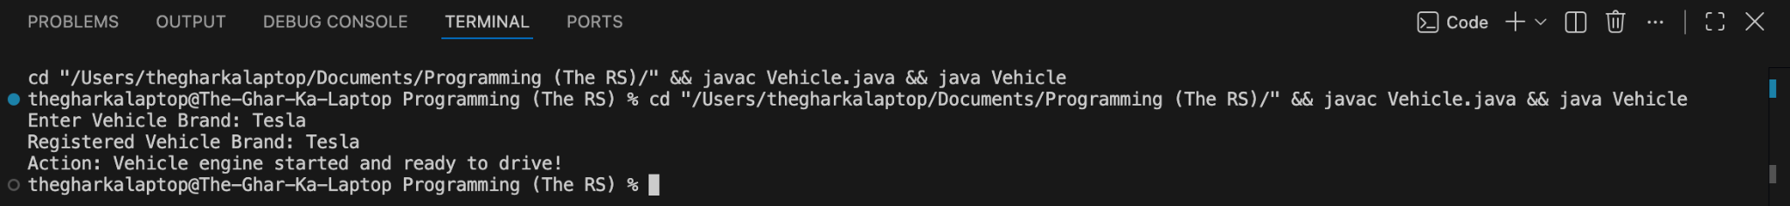

FoodDelivery.java
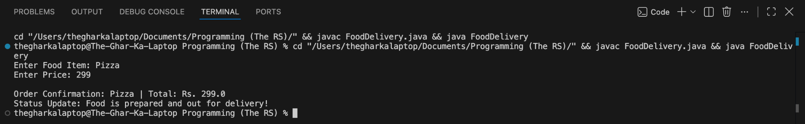

Conclusion:
In this assignment, the concepts of advanced class design and event-driven data handling using inner and anonymous classes were successfully implemented and verified. Inner classes provided strong encapsulation by logically grouping dependent structures within a host class, and anonymous classes allowed quick on-the-fly method overriding without the need to define separate concrete class files.

